**SHREE SHANTI BHAGWATI SECONDARY SCHOOL**

**LETANG-4, MORANG**



A report in field visit of “Manakamana Bee Farm And Source Center”

Letang-9, Jante Morang

Submitted as a part of practical course of

Class 10 Science

**SUBMITTED BY : BIKAL THAPA**

**SUBMITTED TO : HARI SAMPANG RAI**

**DEPARTMENT OF C.E**

**CLASS : 10 (C.E)**

**ROLL NO : 7**

**TABLE OF CONTENT**

1. Introduction……………………………………………………………3
2. Types of honey bee……………………………………………………4
3. Life cycle of honey bee……………………………………………….5
4. Challenges and Products of bee farming….………………………….6
5. Tools used in Apiculture………………….…………………………..7
6. Advantages of honey and honey bee ...........………………………….8
7. Discussion and conclusion……………………………………………9

**INTRODUCTION**

As per the requirement of our syllabus (class 10 science, unit 3 life cycle of honeybee), we the class 10 students (C.E) on the Ashad 3, 2080, headed by our in charge Mr. Santosh Chamlagain , science teacher Mr. Hari Sampang Rai and our class teacher Mr. Hemanta Thapa magar, had gone on educational visit to the "Manakaman Bee Keeping And Source Center" located at letang-9, Jante as seen on the map below.

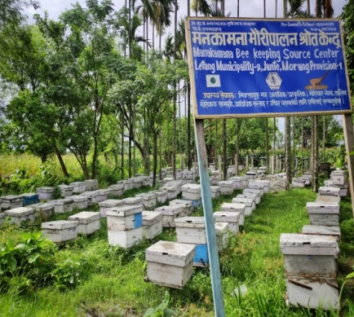

Figure 1: Geological map showing study area (Manakamana Bee Keeping)

The founder of bee farm Imnath Pokhrel and Anish Pokhrel had guide us in their bee farm. The bees were directly observed in the field after having theory class in their meeting room. They explained us about the challenges of honey bee farming that farmers are facing while farming it. They said that they started their journey in bee farming from 8 bee hives and now they reached more than 200 bee hives. There were mainly two kinds of bee in Manakamana Bee Farm. They were *Apis mellifera* and *Apis cerena.* There were more number of *Apis merifera* than *Apis cerena.* The main product produced by them were pollen, propolis, wild honey and regular honey etc. We also observed the types of bees in their bee hives. We also observed different equipments used to harvest and treat bees.

**OBJECTIVE OF THE STUDY**

The main objective of the study were :

1. To observe the different types of honeybees.
2. To study the process of honey making.
3. To study about the different stages of life cycle of honeybee.

**APICULTURE AND APIOLOGIST**

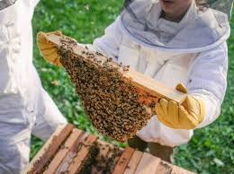Bee farm is the house for bees where different types of bees are kept. It is also a process to maintain bee colony in manmade hive. The farming of bees is known as apiculture and the person expert in apiculture are called Apiologist. Bee farming can be done where there is a presence of large number of flowers and plants because bees requires pollean grains and nectar of flower to feed their baby and to make honey.

**HONEY BEE**

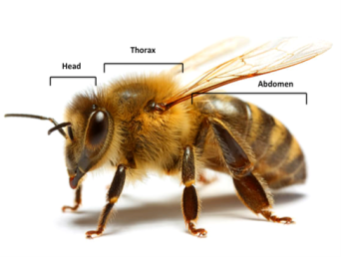Honeybee is a social insects that produces honey, wax and other products. It belongs to the kingdom-animalia, phylum-arthropoda, class-insecta and genus-apis. *Apis merifera* and *Apis cerena* is mostly found in Nepal. They have different color. *Apis merifera*  produce more honey and propolis but *Apis cerena* doesn't produce propolis. Their body is mainly divided in three parts they are head, thorax and abdomen. Honeybees contains pair of antenna and eyes in their heads to produce royal jelly. It has also six pairs of legs. There are three types of honey bee they are explained below:

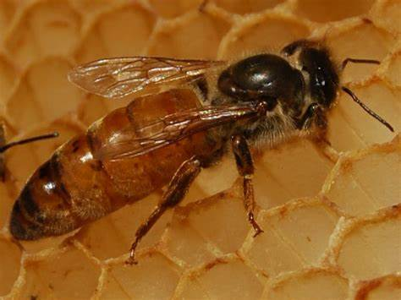**1)** **Queen Bee**

It is the largest size of bee in bee hive that unites all types of bees in hive. It is fertilized female bee. It has small head as compared to worker and drone bees. It can sting more than one because it has a power to regenerate stings. It secretes the smell that makes all the bee in the colony united. Their life span is approximately 2 to 5 years. It feeds upon royal jelly throughout their lifespan.

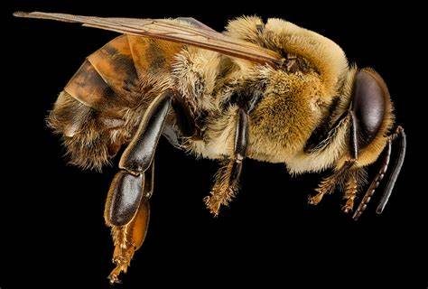**2)** **Drone Bee**

It is the medium size male bee in the hive. It is produced from unfertilized eggs and are haploid. There may be 500 or more than 500 drone bees in single hive. This types of bees are the most lazy bees. It doesn't contains stingers to prevent from other attackers. The main function of drone bee in a hive is to mate with queen bee. Their lifespan is generally two months. They die after mating or weather conditions.

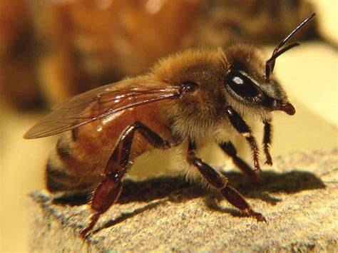**3) Worker Bee**

As the name suggested it is the most active and hard working bees in the hive. Most of the time they are found to be busy. A hive may have 20,000 to 80,000 workers bee. Their lifespan is about 6 weeks to 6 months. They contains stingers which helps them to tackle with their enemy. They collect pollen and nectar of a flower by travelling a far distance.

**LIFE CYCLE OF HONEY BEE**

The life cycle of honey bees has four stages: egg, larva, pupa, and adult. The queen lays eggs in each cell of a honeycomb. The fertilized eggs hatch into female worker bees, while the unfertilized eggs hatch into male drones. The development time varies among the three types of bees: 16 days for queens, 21 days for workers, and 24 days for drones. The bees undergo complete metamorphosis, which means they change their physical form from larva to adult.

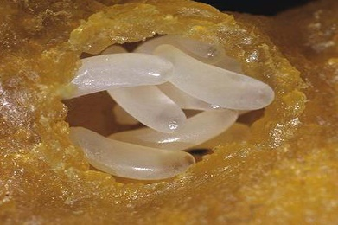**Eggs**

The egg stage is the beginning stage of lifecycle of honeybee. In this phase, the nervous system, digestive system, and outer covering begin to form. The eggs are fragile and require the right temperature and humidity to ensure proper development. After three days, the eggs will hatch into larvae which will be fed by worker honey bees with honey, royal jelly and other liquids from plants.

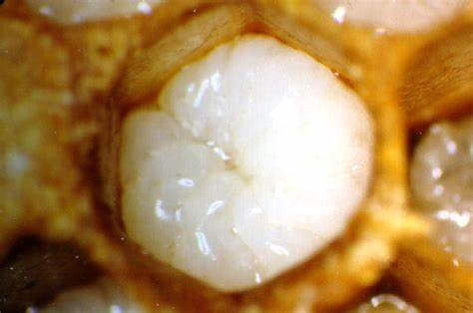**Larva**

Larva stage is the second stage of life cycle of honey bee. In larval period of honeybee worker bee feed larva bee with royal jelly and honey. Queen bee is fed with royal jelly throughout their life span. But the worker and the Drone bees are fed with royal jelly only for first three days.

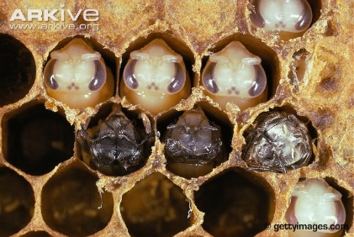**Pupa**

The pupa stage is a vital phase in the life cycle of honey bees, as it marks a significant transformation from a larva into a fully developed adult bee. This metamorphosis process takes place within the safety of a capped cell, allowing the bee to develop undisturbed.

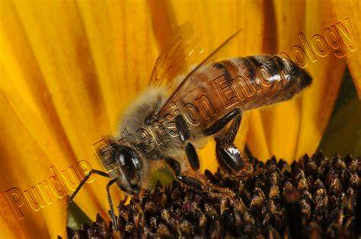**Adult**

It is the final stage in the lifecycle of honey bee. They crawl out of the brood cells by cutting the cocoon and the cell cup with their mandible. Among the types of bees, the worker bees have very important function. So, they immediately join with other bees to perform various function.

**CHALLENGES OF APICULTURE**

The major challenges of Apiculture in the context of Nepal are given below:-

1. Many people are not aware about the benefits of raring honey bee.
2. Sometimes honeybee may collect impurities so, making pure plant honey is difficult.
3. The different chemical fertilizers using in field may kill honeybees and it also effects the growing larva.

**PRODUCTS OF HONEY**

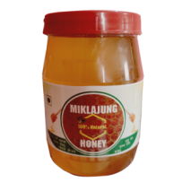Honey is used in a variety of products such as food products, candles, skincare, cosmetics, and medicine. Other products that come from bees include beeswax, propolis, pollen, royal jelly, and honeycomb. Some of the food products that can be prepared by honeybees are explained below;-

**Mustard Honey**

Mustard honey is a pure, unprocessed honey made from the nectar of mustard flowers only. The mustard honey can be prepared in those season where mustard flower blooms. It's cost is low among all the honey because the bees doesn't have to go away for collecting nectar and pollen.

**Mixed Honey**

Mixed or jungali honey is a type of honey produced by the wild bees. It is impure since, it contains pollen and nectar of different flowers. The price of mixed honey in Nepal is approximately RS 850 / kg. The hive of mixed honey can be found in holes of trees and caves.

**Royal Jelly**

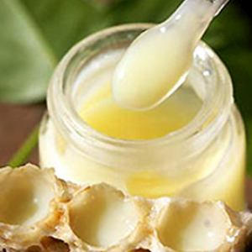It is a milky secretion made by worker honeybees (Apis mellifera). The price of royal jelly is moe than 70000/kg. It is used in the nutrition of larvae and adult queens. It is necessary for queen larva to feed upon royal jelly to be fertile and strong. It's rich in carbs, protein, amino acids, fatty acids, vitamins, and minerals. People sometimes use royal jelly as a form of apitherapy, or alternative medicine that uses bee products.

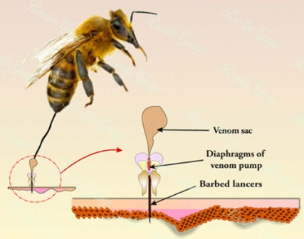**Bee Venom**

Bee venom is a colorless, acidic liquid. Bees excrete it through their stingers into a target when they feel threatened. It contains both anti-inflammatory and inflammatory compounds, including melittin, apamin, adolapin, etc. Bee venom is used to make medicine. It is used for disease such as multiple sclerosis (MS), rheumatoid arthritis (RA), and painful conditions such as tendinitis and bursitis.

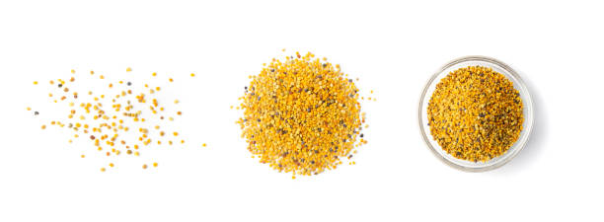

**Propolis**

Propolis is a resinous-like substance produced by bees collected from plants that is used to protect and maintain the structural integrity of the hive. It is useful for medicinal purposes for centuries. It has been used to treat wounds and infections.

**TOOLS USED IN APICULTURE**

There were different types of equipments used in the farm. Some of the instrument was used to harvest honey and some of the instruments was used to be same from bee bite. The equipments observed in the farm are explained below:-

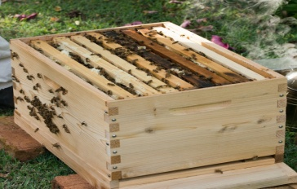**1)** **Bee hive**

A Bee hive is a enclosed man made wooden container where different types of bees are produced and grow. It might be natural also because wild bees make their hive in the holes of the trees.



**2)** **Bee Suit**

Bee suit is a special purpose white colored suit which is used to protect our body from bee bites. It can prevent the risk caused by the bee while harvesting it. It also helps in visibility of bees.



**3)** **Queen Cage**

It is a small cylindrical shape plastic cage which is used to transfer queen from one bee hive to another. It is also used to determine whether the worker and drone bee accepts the new queen bee or not. It is effective when one hive is infected with disease and we have to transport queen to another hive.

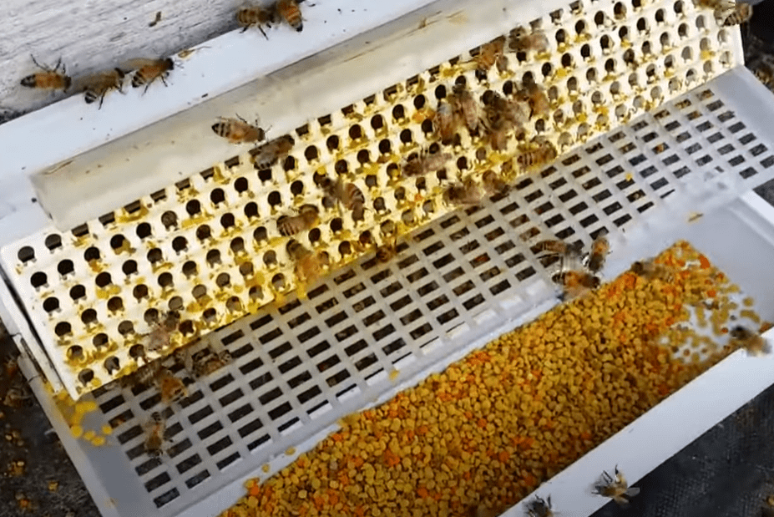

**4)** **Pollen Trap**

This is an equipment that is placed into the hive entrance and forces the worker bees to crawl through tiny openings as they enter the hive. These tiny openings strip the pollen from the worker bees’ legs which will then fall into a tray.

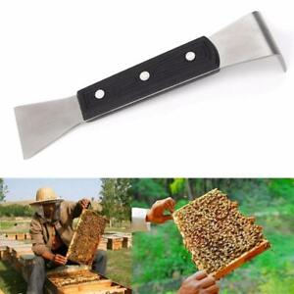

**5)** **Hive Opener**

An opener is an small and portable instrument like a bottle opener that is used to open bee hive.

**ADVANTAGES OF HONEY AND HONEY BEE**

Honey bees have many advantages in the field of medicine, biology and personal health. Some of the advantages of honey bees and the honey produce by them are given below :-

1) Honey can be used as medicinal purpose so it is used to cure different diseases.

2) The systematic work division of honey bees if of great importance to anthropology.

3) Royal jelly and Pollen Propolis produced by the honey bee can be sold at higher cost.

4) It also helps in people's livelihood.

5) Honey bees are the major agent in pollination.

6) The wax produced by honeybee is used to make candles.

7) It lowers the risk of cancer, allergies, arthritis and heart disease.

**DISCUSSION AND CONCLUSION**

In Nepal there is presence of large numbers of flowering plants, so Nepal has large probability in bee farming. If it is reared commercially it can make much profit. Bee farming can also be implemented in medical sector, so it has wide range of scope in Nepal.